Specialist Test 2 Notes – Year 11 2023

By Ajay Bisnath

**Vectors:**

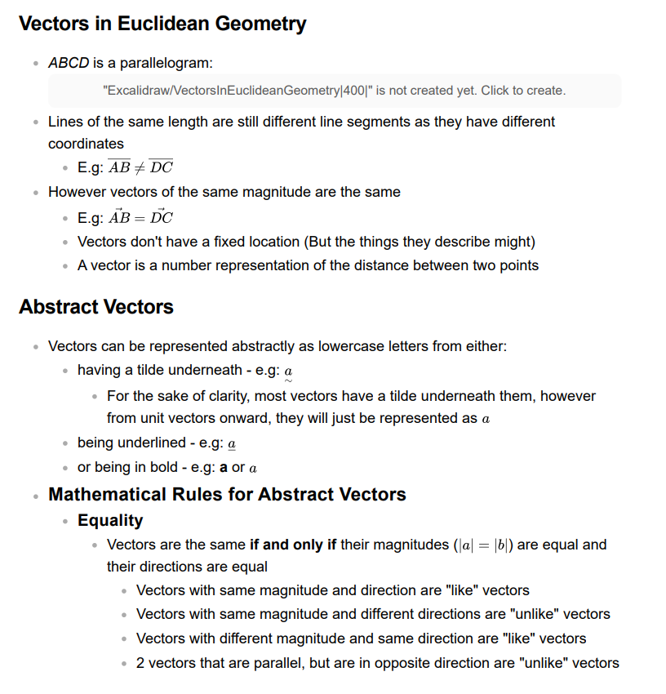

**If you solve something with ClassPad put:**

equation (e.g: x + 5 = 12)  
 (e.g: x = 7)

